Calculator Hex
A game for 2 players

Easy Version

Players take it in turns to:
3 4 5 6 7 8 9
- Pick a hexagon on the board
- Pick two numbers from the pool that multiply together to give the number in the hexagon (You can pick the same number twice)
- Cover the hexagon with a counter if the result is correct

The winner is the first player to make a path of counters connecting their sides of the board.

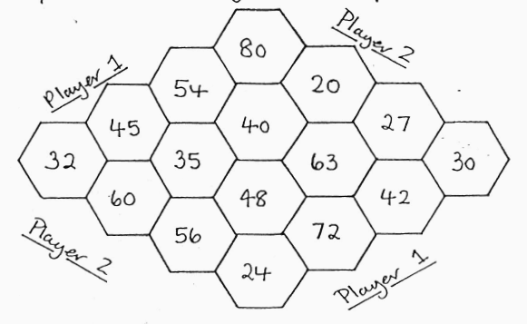

Calculator Hex
A game for 2 players

Harder Version

19 99 29 39
- 59
69 79 89 99

